The Prophetic Jewish, Interfaith & Secular Voice to Heal and Transform the World
Read Our Magazine Donate Our Podcast Join our NSP Activist Community
- Past Issues
- About Tikkun
- Community Activism
- Rabbi Michael Lerner
- Tikkun Institute
- Beyt Tikkun
- Contact
- Politics & Society
- Ecological Transformation
- Justice for All
- Israel/Palestine
- Emancipatory Spirituality
- Jewish Wisdom
- Global Capitalism
- Arts & Cultural Critique

God is Here: Reimagining the Divine

Book Review of Toba Spitzer’s book

By Rabbi Nancy Fuchs Kreimer | March 15, 2022
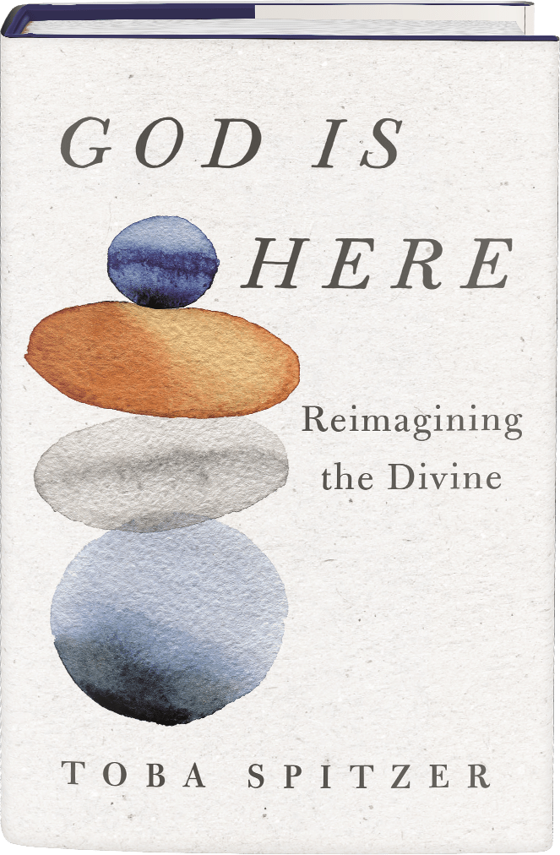
Find a Local Bookstore - Click here
Book Review:
God is Here: Reimagining the Divine, by Toba Spitzer
St. Martin’s Press, 2022,
Imagine a person—let’s call her Jane. Jane has deep intuitions of awe, wonder, and the mystery of life. If she were comfortable with the word, she would say she has known grace. She cares about making the world a better place, and she strives to shape her own disposition and character into a better version of herself, a person with more courage and compassion. She has meditated and practiced yoga. She cannot, she will not pray to the God who is the Big Powerful Person, the King, the Commander-in-Chief. Yet, like Martin Buber (to whom we will return at the end of this review), she is open to using the word God as the place to put her most intimate questions, her yearnings, her resolve to cheat despair. She just doesn’t know quite where that God is.
Imagine that, with luck, Jane’s rabbi is Toba Spitzer, someone who has spent more than twenty-five years serving a congregation with people like Jane. Rabbi Spitzer has done a lot of learning, and a lot of living. She knows how to gently guide someone like Jane to understand that God is a word that can be redeemed and that once it is redeemed, there are practices, ancient and modern—even prayers—that will enhance her life.
Because she is one of the fortunate ones, she has Rabbi Spitzer by her side for the journey. For the rest, there is Spitzer’s wonderful new book, God is Here. I can’t wait to hand this book to all the Janes I know, not to mention rabbis and other clergy who, like me, will read and reread it, grateful beyond measure.
I opened God is Here with exceedingly high expectations, and I was not disappointed. Rabbi Spitzer is one of our most intelligent and thoughtful Reconstructionist rabbis, a leader in the non-Orthodox Jewish world. Indeed, she calls upon multiple Jewish sources—biblical, rabbinic, Hasidic, and mussar texts— along with a host of contemporary writers, from visionary science fiction author Octavia Butler to feminist activist adrienne marie brown. Throughout, Spitzer’s gifts as a teacher, preacher, and spiritual guide shine through.
Rabbi Spitzer knows her people. Recent studies show that the fastest-growing religious denomination is SBNR—spiritual but not religious. It is not news that many people can’t believe in God the King, the Lord, the Law Giver. What may be news is how many are potentially open to figuring out other names for the Divine, or to re-envisioning the name “God”. Rabbi Spitzer knows that what many of these people need is an entirely new access point, a new way of thinking about the whole issue of who or what God is. Rabbi Spitzer wants to salvage the name “God”—not to make an arcane theological point, but to offer food and drink to the hungry and thirsty.
To use a central metaphor in this book, Spitzer wants to offer seekers an expanded menu. She reminds us that there are other human metaphors for God besides King (God as Parent, as Beloved, as Teacher), but her project here is to offer an array of non-human metaphors, drawn from the natural world, metaphors such as water, fire, rock, cloud. These metaphors are both new and old! They have a pedigree in the Bible, and they speak to our consciousness in this moment of ecological awareness, allowing us to relate to our ancient ancestors who were connected to their land. Most important, they give us multiple ways to connect to the Divine.
Even readers who are comfortable with addressing God as You will discover new joys through this project. As Spitzer explains, metaphors do not define God; they provide access to the experience of God. I read the chapter about water aloud to my partner on the way to a day at the ocean. Upon arrival, I found my heart expanding as I met my Friend (my own favorite metaphor for God) in a different guise.
Rabbi Spitzer does more than simply expand the menu. Every lived tradition, including ancient philosophical systems like Stoicism, includes disciplines or activities that ensure the system comes alive in the experience of the believer and trains the believer to live into the system’s values. Rabbi Spitzer offers multiple practices for every metaphor she introduces. Most of us are familiar with Jewish food blessings and are aware of the cottage industry that has grown up around gratitude journals. But here, as she does in each chapter, Spitzer takes what might be familiar to the next level and in different directions. She suggests that it is also good to practice receiving appreciation. And why not keep a curiosity journal, to begin to appreciate not only the welcome but the unwelcome surprises in our lives? This practice, like many others in this book, feel especially relevant to our COVID times.
Rabbi Spitzer is careful to make practical suggestions and offer adaptations as necessary, making her practices both compelling and doable. You don’t have a fireplace to gaze into? Watch a YouTube video of a crackling fire. You want to chant the beautiful words of Psalms? Rabbi Shefa Gold’s website will offer you ways to learn the words and music. Spitzer’s offerings include rewritten traditional blessings, familiar blessings used in new ways, and even some blessings that I, for one, had never heard of.
She continually reminds us that we are embodied creatures; we need practices that engage us not only from the neck up. Spitzer’s approach to practice is capacious. I loved that she declares watching Queer Eye on Netflix a potential spiritual practice to affirm faith in humanity. (And I had thought it was a guilty pleasure!) She also knows, deeply, that solitary practice can only go so far, and that we humans need community, an insight she sources from the Jewish practice of requiring a minyan for prayer (a minimum of 10 people), the mussar va’ad (a small group working together on Jewish ethical practices), and twelve-step groups.
Personal narrative can serve as a powerful entrée as people try to wrap their minds around the more obscure world of theology, and Rabbi Spitzer knows how to make skillful use of her own life story. Glimpses into her life are judiciously interspersed with a gentle hand. Without turning the book into a memoir, Rabbi Spitzer makes the metaphors and practices come alive through story. We learn of moments of finding her own identity, of awe, of loss and grief, of activism. In especially moving passages, Rabbi Spitzer illustrates God as the source of teaching and guidance by sharing learning from her own parents. And the experiences she shares are not only hers. All these stories take what begins as a menu and make it come to life in a rich and satisfying meal.
Rabbi Mordecai Kaplan, founder of the Reconstructionist movement, does not appear in Spitzer’s book by name, and for good reason. This is a Reconstructionist theology for our time and also a work that has the potential to speak to a much larger audience. Yet Kaplan’s influence is evident in three ways. First, early in the last century, Kaplan believed that science and religion, far from being in conflict, would actually prove to be mutually enlightening. Rabbi Spitzer makes use of the science of cognitive linguistics, in particular the work of George Lakoff and Mark Johnson, in order to help us understand how we make meaning of the world around us and move beyond the question of “does God exist?”.
Second, Kaplan’s emphasis on function is present throughout. At the beginning of the book, Spitzer enumerates the many ways that belief in God has functioned and might function in people’s lives, and then follows up with an effort to reconstruct God language with natural metaphors, demonstrating how different languages might serve the same functions. If traditional God ideas served as a source of meaning, perspective, values, and support in hard times, how much of that can be retained when we turn to non-human metaphors? It turns out, quite a lot.
Finally, Kaplan made use of process theology, based on the philosophy of Alfred North Whitehead, offering a new definition of God as “the process that makes for salvation”, or as some process theologians put it “the potential of potentialities”. This redefinition often appeals to the head more than the heart. Spitzer has also read process theology, but she makes it come alive, speaking to our varied human experience. She offers a plethora of metaphors because she understands that people experience the Divine in multiple ways.
For Kaplan, this effort at reconstruction was needed for twentieth-century American Jews to find their way comfortably into the synagogue and, if not pray, at least find meaning in identification with the Jewish people. He hated to see intellectual scruples and lack of traditional belief keep Jews from participating in Jewish community and life. Rabbi Spitzer has a larger audience. She knows that Judaism has resources—including multiple metaphors, practices, and insights—that can be offered not only to Jews but to seekers of many backgrounds. Judaism can take its place alongside the other world spiritual traditions. It is the sharing of those traditions, “deep ecumenism” as dubbed by Matthew Fox, that is one of the great spiritual adventures of the 21st century.
If I had one quibble with this book, it would be about a word Rabbi Spitzer uses that I wish had been qualified a bit. Spitzer refers to letting go of the “fantasy” of God as “a superhero who will show up and save the day”. It would have been worth pausing there for a minute to say that this “fantasy” is actually also a metaphor, just like the ones she has been offering. That, of course, is actually her whole point. We cannot think about the Mystery without metaphors and pictures, more or less fantastic, to describe that which is beyond words. As the rabbis themselves said, the Torah speaks in the language of humans. (Berachot 31b)
I know that Spitzer has deep respect for people with a variety of hermeneutics and metaphors. That is clear in other places in the book. For example, in a passage in which she talks about people she visited as a pastor in a detention center, Spitzer says, with genuine humility, that they seemed to have more faith than she. She believes that they are people of good hearts and good minds. In Rabbi Spitzer’s experience, some metaphors have proven damaging and others healing. From a pastoral perspective, great harm can be done by some versions of God, and the one Rabbi Spitzer offers has proven, in her own work with people, to be far more psychologically sound. But this passage felt a little patronizing toward the folks who do believe in the superhero, who find that metaphor meaningful, and do not see it as “fantasy.”
The 2021 film “Don’t Look Up,” a darkly humorous satire, portrays a contemporary American society (too close for comfort) as it ignores a coming apocalypse at its own peril. The movie is a far-from-subtle allegory reminding viewers of the ecological disaster that awaits. Three scientists exhibit courage as they confront politicians, journalists, talk-show hosts, and a self-promoting tech guru, to no avail. One of the media folks, knowing the end is nigh and asked if she wants to pray, says “I’d rather drink and talk shit about people.” It is almost an entirely secular, ultimately shallow story, with no hint of transcendence, either within humanity or beyond.
Almost, but not entirely. There is a scene near the end, a family dinner table at which the three scientists (who had tried without success to warn everyone of the coming catastrophe) talk softly with one another and share what they are grateful for. Says one, “I am grateful that we tried.” The scientist with whose “not very religious” family the group is gathered feels something is lacking.
“Maybe an “Amen?” he suggests.
“Amen???” his wife asks. “Just ‘Amen’?”
And then, out of the blue, the boyfriend of one of the scientists, an earnest hippie evangelical (an improbable late addition to the group), says “I’ve got this”. Everyone joins hands, bows their heads, and is led, with reverence, in a prayer. “Dearest Father and Almighty Creator, we ask for your grace tonight despite our pride, your forgiveness, despite our doubt. Most of all, Lord, we ask for your love to soothe us through these dark times.”
The Hollywood writers may have not meant this to be quite as poignant a scene as it felt to me. Not wanting to give it the final word, they added not one but two cynical jokes after the credits roll, more jabs at the bleak prospects for the human endeavor. But that prayer is a moment of light in a very dark world. Its metaphors are not those of Rabbi Spitzer, but I feel certain she would honor the power of that scene. In the end, it is all metaphor, both the Father and Lord who loves us and the many beautiful natural images Rabbi Spitzer provides in this book. And in those moments when the comet is about to hit, or something far less dire but equally disorienting, they are not metaphors at all. Just the One we call out to, not merely describe in metaphor, but address as You, in something we might call faith.
We return, as promised, to Buber. Realizing how much good and evil have been done in the name of God, how many have rejected the name because of the injustices it has authorized, and how many others have given their lives for it for reasons both noble and problematic, Buber concludes that, in the end, there is really no better word than God.
“If I took the purest, most sparkling concept…I could not capture the presence of (that) whom the generations of men have honoured and degraded with their awesome living and dying….We cannot cleanse the word ‘God’ and we cannot make it whole; but, defiled and mutilated as it is, we can raise it from the ground and set it over an hour of great care.” (Martin Buber, Eclipse of God (London: Gollancz, 1953), 17-18.)
We are in such an hour, and this beautiful book will help many of us raise up that Name.

